How to measure for roof lantern blinds
When measuring for roof lantern blinds the first thing you need to do is to decide where in the recess you are going to fit the blind. This location depends a lot on your particular circumstance eg how deep is your recess? Also some of our products are only suitable for installation at certain points in a recess.
SkyFIT™ Manual Blind : Must be fitted at the bottom edge of the recess (flush with the ceiling)
SkyFIT™ Motorised Blind: Can be fitted anywhere in the recess
LanternLITE™ Honeycomb blinds (including OPENVIEW): Can be fitted anywhere in the recess
LanternLITE™ Zip & Twin Zip Blinds: Must be fitted at least 10cm up from the bottom of the recess
- Decide Where in the recess to Fit your Blind
- Mark with a pencil
- Measure the width & length in 3 places making no deductions (wall to wall – this is the RECESS SIZE).

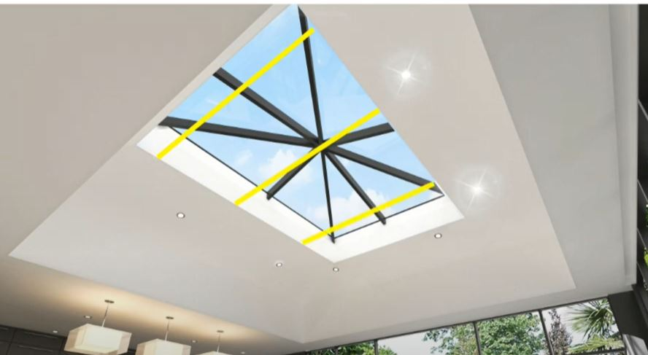 | 